Tutorial 7b

1. Try the following program. In this program, the library ieee.numeric_std is used. 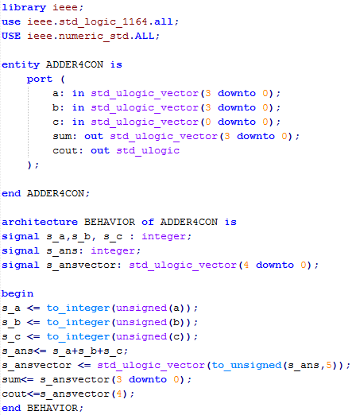
2. Remove the numeric_std library. Which code/function is affected?

to_integer and to_unsigned

1. Note that input c uses std_ulogic_vector instead of std_ulogic. Why?

to_integer required a vector type

1. Create a testbench for the ADDER4CON to display the following output. Explain why the output sum=9 and cout=1 when a=15 and b=10.

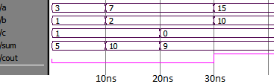

Because cout=1 is equal to “0001” and sum=9 is equal to “1001”, which when appended together becomes “11001”, which is equal to 25.

1. The following program demonstrates the use of package and function. Two files called converter.vhd (**Figure 2.1**) and conversion.vhd (**Figure 2.2**) are provided. The converter.vhd is the main file that perform basic arithmetic while coversion.vhd is a program where package and function are declared. There are two functions in the program to convert u_logic_vector to integer (i.e. function to_unsigned) and integer to u_logic_vector (i.e. function to_vector). Create a testbench that can display the output shown in **Figure 2.3**.

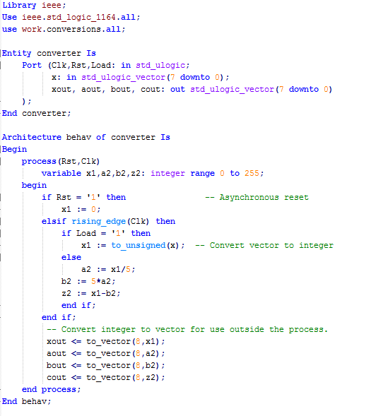

**Figure 2.1:** converter.vhd

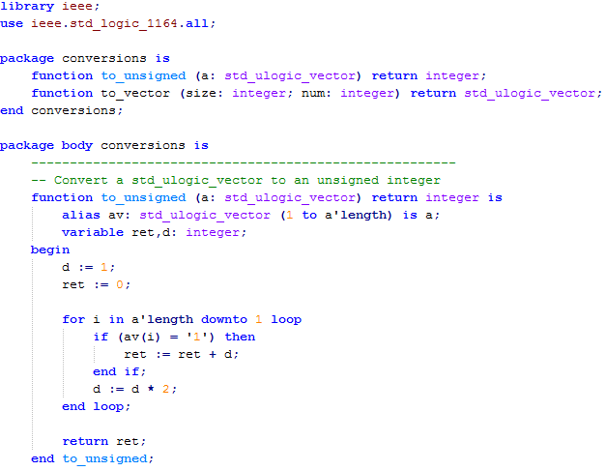

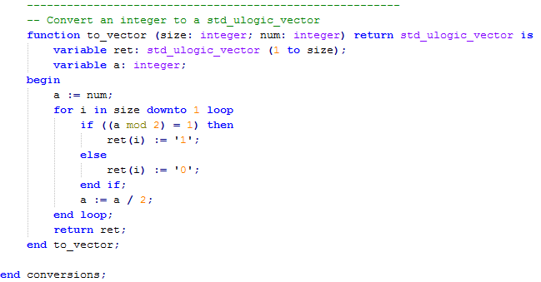

**Figure 2.2:** conversion.vhd

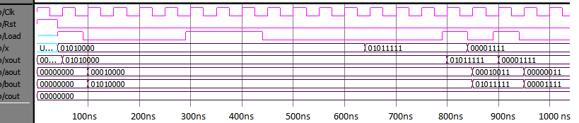

**Figure 2.3:** Waveform for question 2

1. Based on the program in question 2, create a package called logicPack and a function called andpack(A,B). The andpack is used to do AND operation for any two n-bit numbers declared as std_logic_vector. Example of a main program for 4-bit input is given as below (the andpack should be able also to AND other input length (e.g. 2, 3, n-bit) ).

library ieee;

use ieee. std_logic_1164.all;

use work.logicPack.all;

entity funcAND is

PORT( A,B: in std_logic_vector(3 downto 0);

Q: out std_logic_vector(3 downto 0));

end funcAND ;

architecture behavioral of funcAND is

begin

Q<= andpack(A,B);

end behavioral;